**Eavesdropping Assignment**

**Group Members:** Nina Onwuachi (10190678)

                                Abigail Brown (30214975)

                    Sarah Kaunain Syeda (30220873)

Exercise 2:

1.

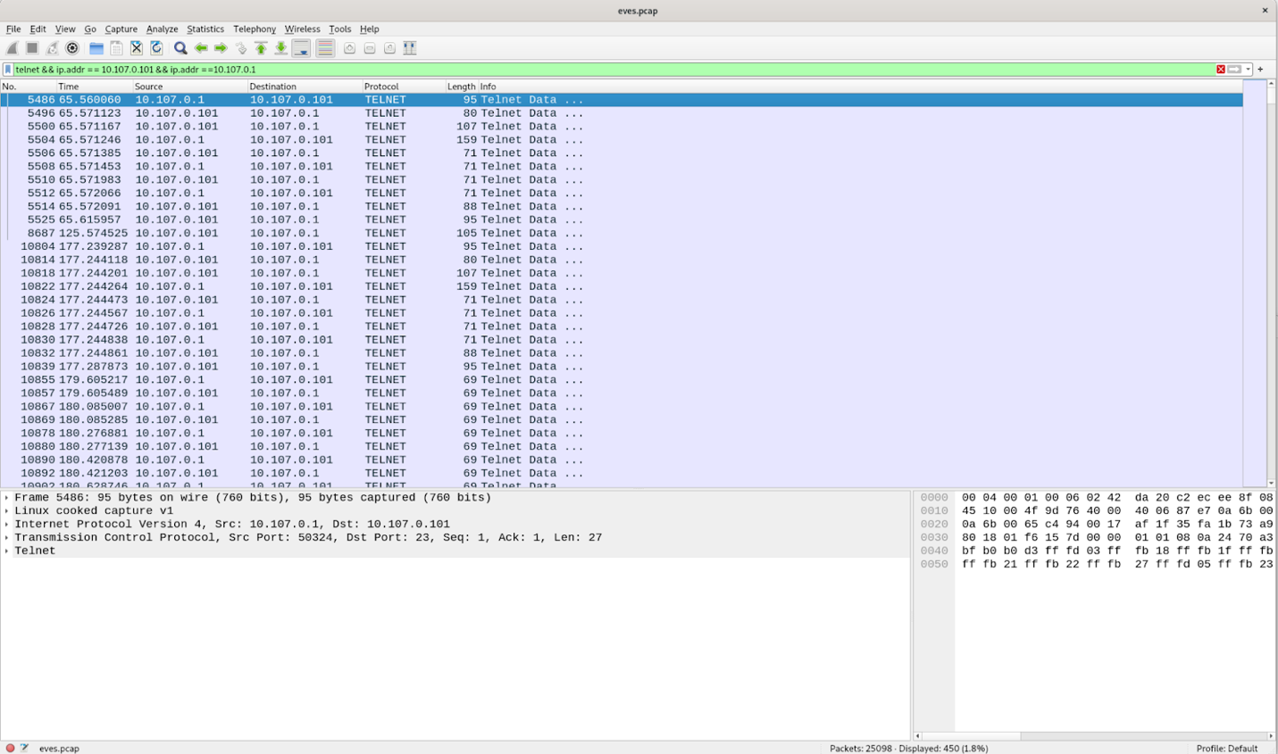

2. YES, do the above filter and follow the tcp stream or

frame contains “admin”

3. Packets: 450

Packet length: 45.840KiB

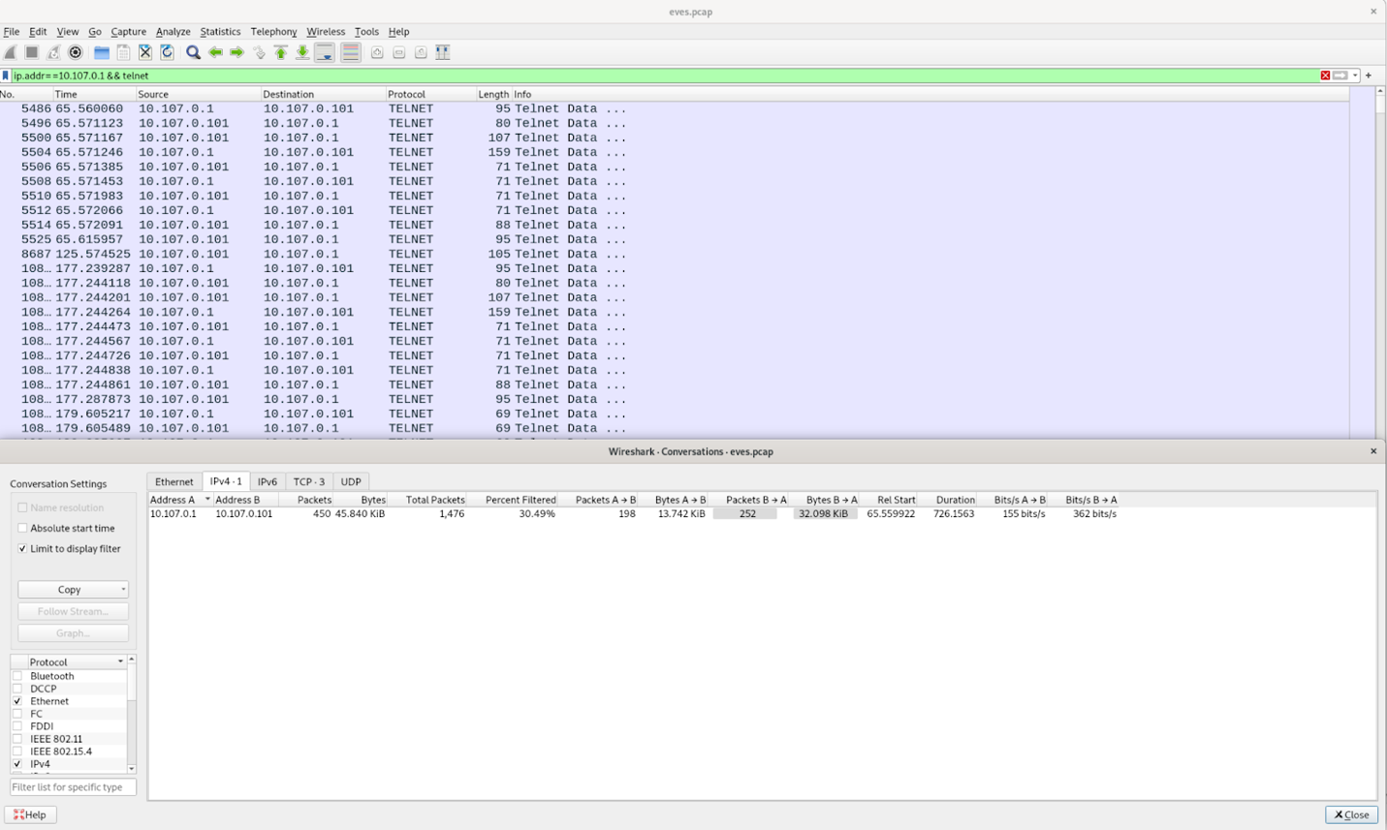

1. Packet range 5486-24697

2. REQUEST and Response

3. Yes

4.

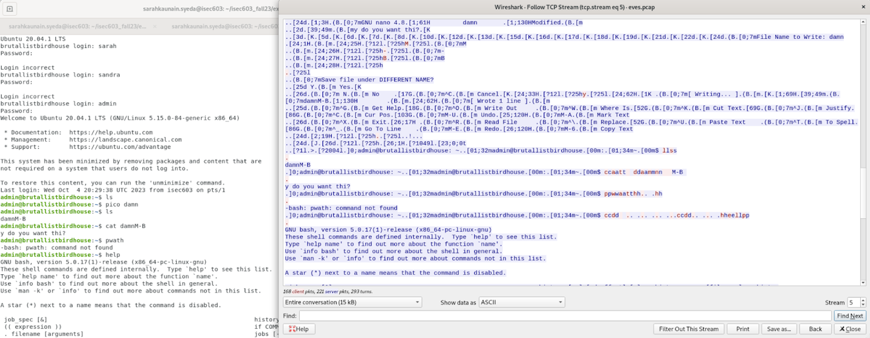

EXERCISE 3: SSH

1. 1 TCP connection

2. send is 8.696KiB

received is 10.372KiB

3. No

1. filter with syn packets in Wireshark and check any differences between them.

a.The time scp transfer takes is much larger. Also timing in scp transfer is much consistent since there is a burst of packets with larger payload sizes whereas the timing in the interactive session is irregular and corresponds to the user typing commands (e.g., typing 'ls' and pressing Enter) and receiving responses from the server.

b. The byte sizes of packets is also much larger in scp.

2.

3.height of the spike

1. One ssh connection

